
PROJECT REPORT
Course Title: Artificial Intelligence Lab
Course Code: CSE0613312
Project: Author Identification and Text Generation Using Markov Model
Submitted to:
Name: Md. Faysal & Most. Thasin Sabira
Designation: Lecturer
Submitted by: Group 01-Team CodeCrafters
Team Members
Maliha Mahjabin Tasnim | 04324205101199
Maimuna Nowshen Mahima | 04324205101208
Maksuda Akter Mohona | 04324205101209
Nusrat Jahan | 04324205101211

Batch: 56
Semester: Autumn
Section: 5C2
Program: BSc
Department: CSE
Date of Submission: 12 November 2026

Abstract
Identifying who wrote a text and producing new text in a given writing style are two classic problems in natural language processing. This project solves both with one fully explainable method: word-level Markov chains. Four public-domain novels from Project Gutenberg, by Jane Austen, Charles Dickens, Arthur Conan Doyle and Mark Twain, are cleaned and split into words. The first 80% of each book is used for training and the last 20% is cut into 1,873 unseen 50-word test passages. For each author the system counts how often each word follows the previous one or two words, and turns the counts into transition probabilities with add-k smoothing (k = 0.01) over a shared vocabulary of 16,313 words. An order-2 chain writes new sentences by a weighted random walk, and an order-1 chain identifies the author by choosing the model that gives a passage the highest log-probability. On the unseen passages the detector reaches 83.7% average accuracy (84.7% of all passages correct), compared with 25% for random guessing and 31.0% for always predicting the largest class. Accuracy rises to 95.8% for 200-word passages. Higher-order chains write more natural text but detect worse (71.3% for order 2 and 53.6% for order 3), because most longer word sequences never appear in the training text. A word-frequency baseline (order 0) scores 88.8%, showing that with one book per author much of the style signal lies in vocabulary. The system uses only the Python standard library and offers a console menu and a browser interface.
Keywords: Markov chain, authorship attribution, text generation, n-gram language model, smoothing, stylometry.

Author Identification and Text Generation

Version: 1.0.0
Date: 12-11-2026
Prepared For: CodeCrafters Team
Prepared By: Maliha Mahjabin Tasnim, Maimuna Nowshen Mahima, Maksuda Akter Mohona, Nusrat Jahan

Table of Contents
Abstract 2
1. Introduction 5
1.1 Background and Motivation 5
1.2 Problem Statement 5
1.3 Objectives 5
1.4 Scope and Limitations 6
2. Literature Review 6
3. Problem Description 7
4. Tools and Environment 8
5. Model Formulation 8
5.1 Markov Chain or Hidden Markov Model? 8
5.2 States 8
5.3 Markov Assumption 9
5.4 State Transition Diagrams 9
6. Parameter Estimation 10
6.1 Data Source and Preparation 10
6.2 Initial Probabilities (π) 11
6.3 Transition Matrix (A) 12
6.4 Checking That Each Row Sums to 1 12
7. Algorithms and Worked Example 13
7.1 Training 13
7.2 Sequence Probability and Author Identification 13
7.3 Text Generation 13
7.4 n-Step Prediction and Steady State 13
7.5 Worked Example 1: Identifying the Author of “my dear sir” 13
7.6 Worked Example 2: Two- and Three-Step Prediction 14
7.7 Worked Example 3: Steady-State Distribution 15
8. Implementation, Results and Analysis 15
8.1 System Design 15
8.2 Code Snippets 15
8.3 Screenshots 16
8.4 Generated Text 18
8.5 Author Identification Results 18
8.6 Steady-State Distribution and Its Meaning 20
8.7 Comparison with Baselines and How Well the Markov Assumption Holds 20
8.8 How Predictions Change When the Probabilities Change 21
9. Discussion 23
10. Conclusion and Future Work 23
11. References 24
12. Appendix 25
A. Source Code 25
B. User Manual 25
C. Additional Results 26
Contribution Table

1. Introduction

1.1 Background and Motivation
Every writer has habits: favourite words, typical sentence lengths, and phrases that appear again and again. Stylometry turns such habits into numbers so that a computer can compare writing styles. The idea is old. In 1963, Mosteller and Wallace used the rates of common words to decide that James Madison wrote the twelve disputed Federalist Papers [3], and modern surveys describe many statistical and machine-learning methods for the task [7].
The question “who wrote this?” matters in Bangladesh too. Bangla literature has a large body of work by classic and modern writers, and Bangladeshi researchers have started to build Bangla authorship datasets and models [6]. Universities need ways to check whether an assignment or report matches a student’s own writing, where a style comparison can support (but never replace) a plagiarism check. Anonymous posts on social media can spread rumours, and investigators sometimes look for evidence about who wrote them. At the same time, students who learn Artificial Intelligence need examples that show how a probabilistic model works from the inside rather than as a black box.
Markov models suit all of these needs. Their probabilities are counted directly from text, every number can be checked by hand, and the same model can both score an existing text and generate a new one. In 1913, Andrey Markov applied his chains to the sequence of vowels and consonants in Pushkin’s Eugene Onegin [1], and Claude Shannon later used word-level chains to generate English-like text [2]. This project applies the same idea to four English novelists, because large, clean and copyright-free texts are available from Project Gutenberg [9]. The code works the same way for any language once a suitable tokenizer is provided, so it can later be extended to Bangla.

1.2 Problem Statement
Given a short passage of English prose, the system must decide which of four known authors most probably wrote it; given an author, it must generate new text that follows that author’s word patterns. The solution must be a transparent probabilistic model whose parameters are counted from the authors’ books, and its accuracy must be measured on text the model has never seen.

1.3 Objectives
1. Build word-level Markov chain models (orders 1 to 3) for four authors from Project Gutenberg books, using only the Python standard library.
2. Identify the author of unseen 50-word passages with an average accuracy of at least 80%, far above the 25% expected from random guessing.
3. Generate new sentences in the style of each author with an order-2 Markov chain.
4. Provide a simple interface (console menu and web page) and measure how model order, smoothing and passage length change the accuracy.

1.4 Scope and Limitations
In scope: four English authors with one novel each; word-level Markov chains of order 0 to 3; closed-set author identification among these four authors; text generation; evaluation on held-out passages; a console menu and a local web interface.
Out of scope and limitations:
- The system only chooses among the four trained authors. A passage by any other writer is still assigned to one of them.
- Training and test passages come from different parts of the same book, so character names and story topics help the detector. Accuracy on a different book by the same author would probably be lower.
- The model does not understand meaning or grammar. It only uses word sequences, so generated text is fluent over a few words but not over whole paragraphs.
- Only English text is handled. Bangla text would need a Unicode tokenizer and a Bangla corpus.
- The project does not attempt to detect AI-generated text or to work on very short messages; passages under 5 words are rejected.

2. Literature Review
Authorship attribution and text generation both rely on statistics of word or character sequences. Table 1 summarizes six works that are closest to this project, from the origin of Markov chains to recent work on Bangla.
Author (Year) | Method | Data / Problem | Result | Limitation
Markov (1913) [1] | Two-state chain (vowel / consonant) with transition probabilities | 20,000 letters of Pushkin’s novel Eugene Onegin | Showed that each letter depends on the previous one; first application of Markov chains to text | Letter level with only two states; no authorship or generation task
Shannon (1948) [2] | Letter and word n-gram (Markov) approximations of English | Statistical structure of English text | Higher-order approximations produce increasingly English-like text | Illustrative generation only; no author identification
Mosteller & Wallace (1963) [3] | Bayesian inference on the rates of function words | 12 disputed Federalist Papers: Hamilton or Madison? | Attributed all 12 disputed papers to Madison | Uses word rates only, not word order; two candidate authors
Khmelev & Tweedie (2001) [4] | First-order Markov chains of letters; author with the highest likelihood wins | Russian texts and English texts from Project Gutenberg | Outperformed lexical-richness measures on their English test | Letter transitions only; no text generation
Peng et al. (2003) [5] | Character n-gram language models with smoothing | Greek, English and Chinese authorship data sets | State-of-the-art results; about 18% better than the best published result on a Greek data set | Character level; no generation; needs choice of n and smoothing
Khatun et al. (2019) [6] | Character-level convolutional neural network with pre-trained character embeddings | Bangla literature, 6 to 14 authors | 2–5% below the best word-level models but much faster and smaller; pre-training improved accuracy by up to 10% | Neural model is hard to explain and needs training infrastructure
Table 1: Summary of related work

Gap addressed by this project. The works above either identify authors without generating text [3]–[6] or generate text without identifying authors [2]. The strongest recent systems use character n-grams or neural networks [5], [6], which work well but are harder to explain step by step, and the Bangla study needs a deep-learning setup. There is room for a small and transparent system in which one word-level Markov chain per author both identifies the author of a passage and writes new text, where every probability can be traced back to counts in the book and checked by hand. This project builds such a system and measures honestly where the simple model succeeds and where it fails.

3. Problem Description
The real-world system is a small text-analysis tool. Its users are students who want to see how a probabilistic language model works, teachers who want to compare the style of a piece of writing with known authors, and readers who are curious about writing styles. The tool has two jobs: it guesses who wrote a passage, and it writes new text in a chosen author’s style. Table 2 lists its inputs and outputs.
 | Inputs | Outputs
Training | One plain-text book per author (downloaded once from Project Gutenberg) | One Markov chain per author and model order
Author identification | A passage of at least 5 words, typed or pasted, or a random unseen test passage | The predicted author and a ranking of all four authors with their log-probability scores
Text generation | An author and the number of sentences (1–5) | New sentences that follow the author’s word patterns
Evaluation | All 1,873 unseen 50-word test passages | Accuracy per author and model order
Table 2: Inputs and outputs of the system

What changes in sequence. A text is a sequence of tokens w₁, w₂, …, w_{T} that is read in order. At each position the next word is uncertain, but some continuations are much more likely than others, and the likely ones differ between authors. For example, after the word “my”, Jane Austen writes “dear” 17% of the time, while Arthur Conan Doyle does so only 3% of the time (Section 6.3). The state of the process is the most recent word (order 1) or the two most recent words (order 2), and the process moves from state to state as each new word is written.
Why a probabilistic, state-based model fits.
- Language is uncertain: the same context can be followed by many words, so a probability distribution over the next word is the natural description.
- Much of an author’s style is local: favourite phrases, common word pairs and punctuation habits show up in short word sequences.
- The parameters are simple counts. They need no iterative training, and every probability can be explained.
- The same model does both jobs. It gives the probability of a whole word sequence, which is used to identify the author, and it can sample new sequences, which is used to generate text.

4. Tools and Environment
The project was built with free tools and needs no external Python packages. Table 3 lists them.
Category | Tool | Used for
Programming language | Python 3 (tested with Python 3.14) | All model, generation and evaluation code
Standard library | re, os, urllib.request | Downloading, cleaning and tokenizing the books
Front end | HTML, CSS, JavaScript | Browser interface with four tabs
Data | Project Gutenberg plain-text books [9] | Training and test text
IDE and tools | Visual Studio Code, Git and GitHub | Editing, version control and sharing the code [10]
Table 3: Tools and environment

5. Model Formulation

5.1 Markov Chain or Hidden Markov Model?
This project uses a Markov chain, not a Hidden Markov Model (HMM). The states of the process are the words themselves, and the words are observed directly in the text, so nothing is hidden. The unknown author in the identification task is not a hidden state that changes over time: it is one fixed choice for the whole passage. It is handled by training one separate Markov chain per author and comparing how well each chain explains the passage (model selection). Because there are no hidden states, there is no emission matrix B.

5.2 States
A token is either a lowercase word (for example “dear” or “don’t”) or a sentence-ending mark (“.”, “!” or “?”). The state depends on the order n of the chain:
- Order 1: the state is the current token. The next token depends only on this one token.
- Order 2: the state is the pair of the last two tokens, which gives more context and more natural generated text.
- Order 0 (used only as a baseline): there is no state, and each token is drawn from the author’s overall word frequencies.
Table 4 shows how large the chains are. Each author’s order-1 chain has several thousand states, and the order-2 chain has as many states as there are distinct word pairs.
Author | Order-1 states (distinct tokens) | Distinct word pairs (order-1 transitions) | Order-2 states (distinct pairs)
Jane Austen | 6,387 | 48,143 | 48,143
Charles Dickens | 9,049 | 56,396 | 56,395
Arthur Conan Doyle | 7,244 | 42,149 | 42,149
Mark Twain | 6,780 | 34,244 | 34,243
Table 4: Size of the Markov chains learned from the training text

To draw a readable diagram, the thousands of word states can be grouped into three classes. This grouped chain is used for the worked example in Section 7 and for the long-run analysis in Section 8; the real model always uses individual words.
- E (sentence end): the tokens “.”, “!” and “?”.
- P (pronoun): “i”, “he”, “she”, “it”, “we”, “they” and “you”.
- W (word): any other word.

5.3 Markov Assumption
The Markov assumption says that the next token depends only on the last n tokens, not on the whole history:
P(w_{t} | w₁, …, w_{t−1}) ≈ P(w_{t} | w_{t−n}, …, w_{t−1})
This holds only approximately. Short-range patterns such as “my dear”, “do not” and “said the” are captured well, so generated text sounds right over a few words. Long-range dependencies are lost: who is speaking, the topic of a paragraph, an opening quotation mark, or agreement between words far apart in a sentence. Section 8.7 measures this. Most longer word sequences in the test text never occur in the training text, which is why higher orders do not help detection.

5.4 State Transition Diagrams
Figure 1 shows a small part of the real order-1 chain for Jane Austen: the state “my” and its most likely next words. Figure 2 shows the full transition diagram of the grouped three-state chain, also counted from Austen’s training text. In both diagrams the probabilities on the arrows leaving a state add up to 1.
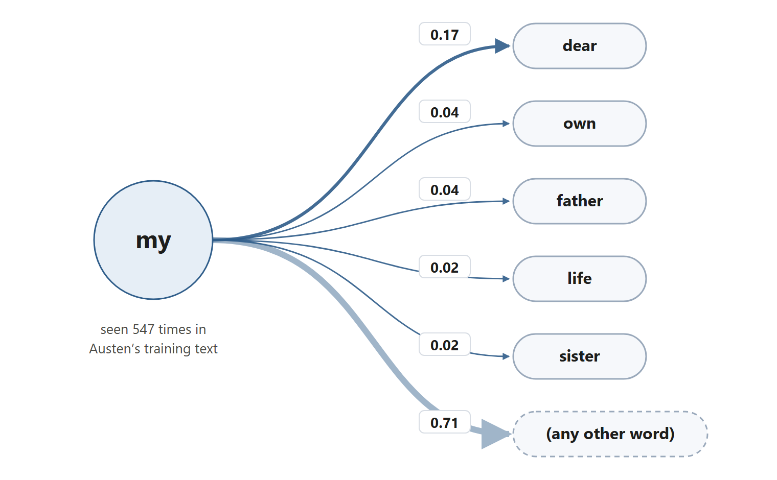
Figure 1: Part of Jane Austen’s order-1 chain: transitions out of the state “my” (probabilities counted from the training text)
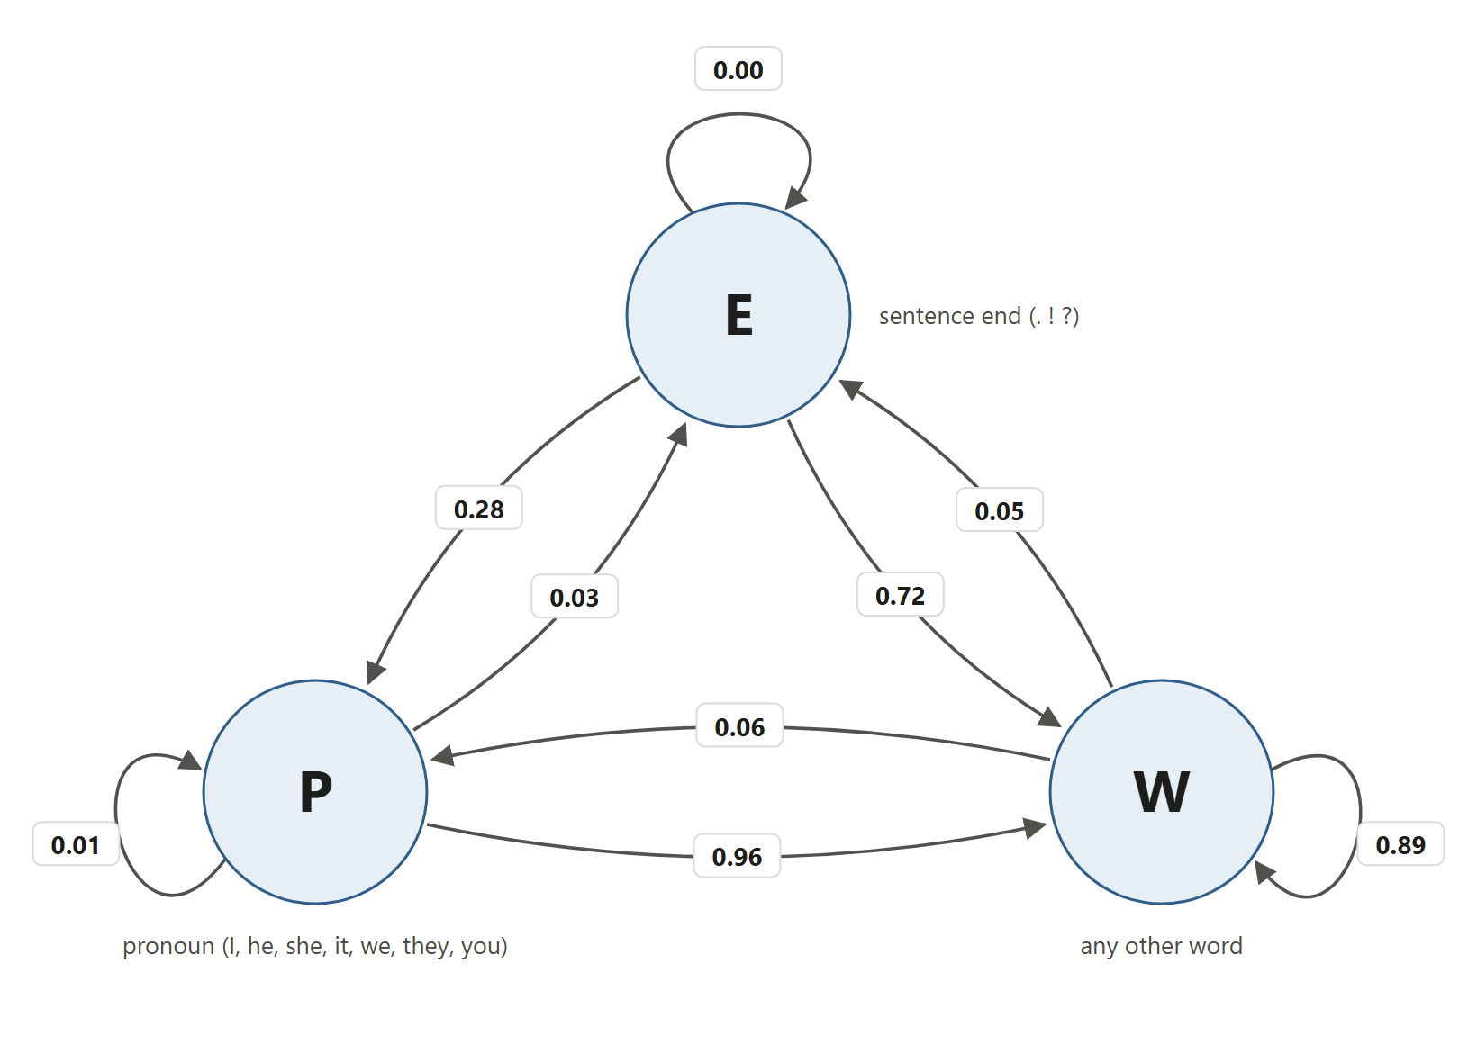
Figure 2: Transition diagram of the grouped three-state chain for Jane Austen (E = sentence end, P = pronoun, W = other word)

6. Parameter Estimation

6.1 Data Source and Preparation
One novel per author was downloaded as plain text from Project Gutenberg [9] (Table 5). All parameters were counted from this data; no values were taken from experts or from the literature.
Author | Book (Gutenberg no.) | Tokens | Training tokens (80%) | Test tokens (20%) | Test passages | Words per sentence
Jane Austen | Pride and Prejudice (1342) | 134,054 | 107,243 | 26,811 | 536 | 20.7
Charles Dickens | A Tale of Two Cities (98) | 145,304 | 116,243 | 29,061 | 581 | 17.6
Arthur Conan Doyle | The Adventures of Sherlock Holmes (1661) | 112,164 | 89,731 | 22,433 | 448 | 15.3
Mark Twain | The Adventures of Tom Sawyer (74) | 77,155 | 61,724 | 15,431 | 308 | 14.5
Total |  | 468,677 | 374,941 | 93,736 | 1,873
Table 5: Data set: one book per author, after cleaning and tokenizing

The text was prepared in these steps (file data.py):
- Download each book once and keep it in the data/ folder, so later runs work offline.
- Remove the Project Gutenberg licence text by keeping only the part between the *** START and *** END lines.
- Convert to lowercase and replace curly apostrophes with straight ones.
- Remove the full stop from “Mr.”, “Mrs.”, “Dr.” and “St.”, so that these abbreviations are not mistaken for sentence ends.
- Split the text into tokens with the regular expression [a-z]+(?:'[a-z]+)*|[.!?]. Words (including forms such as “don’t”) and the marks . ! ? become tokens; commas, quotation marks, digits and other symbols are dropped.
- Use the first 80% of each book for training and the last 20% for testing, and cut the test part into non-overlapping passages of 50 tokens.
The data contains no continuous values, so no discretisation was needed.

6.2 Initial Probabilities (π)
To generate text, the chain must start at the beginning of a sentence. The initial distribution π gives the probability that a sentence starts in state s:
π(s) = (number of sentences that start with state s) / (total number of sentence starts)
During training, the code stores the state that follows every sentence-ending mark in a list. Picking a random element of this list is the same as sampling from π. Austen’s training text has 4,748 sentence starts with 372 different first words; the most common are shown in Table 6.
First word s | i | she | but | the | it | he
Count | 452 | 257 | 241 | 224 | 194 | 169
π(s) | 0.095 | 0.054 | 0.051 | 0.047 | 0.041 | 0.036
Table 6: Most likely sentence-start states π(s) for Jane Austen (order 1)

π is not used for author identification. A test passage is cut from the middle of the book and usually does not start at a sentence beginning, so its score is computed from the transitions only, given its first word.

6.3 Transition Matrix (A)
The transition probability from state s to the next token w is estimated by counting (maximum likelihood):
A(s, w) = c(s, w) / N(s), where N(s) = Σ_{w} c(s, w)
Here c(s, w) is the number of times w followed s in the training text. For example, the word “my” occurs 547 times in Austen’s training text and is followed by “dear” 94 times, so A(my, dear) = 94 / 547 = 0.172. Table 7 compares the same row of A for all four authors and shows clear differences in style.
Jane Austen | 547 | dear 0.17 · own 0.04 · father 0.04 · life 0.02 · sister 0.02
Jane Austen | 547 | dear 0.17 · own 0.04 · father 0.04 · life 0.02 · sister 0.02
Charles Dickens | 437 | dear 0.12 · father 0.05 · life 0.03 · own 0.03 · love 0.03
Arthur Conan Doyle | 771 | own 0.04 · friend 0.04 · dear 0.03 · companion 0.03 · father 0.03
Mark Twain | 82 | ! 0.09 · own 0.05 · old 0.05 · side 0.05 · goodness 0.02
Table 7: Row “my” of the transition matrix A for each author: the five most likely next tokens

Smoothing. A word pair that never appeared in an author’s training text would get probability 0. One such pair would make the whole passage impossible for that author (log 0 = −∞), even if every other word fits well. The model therefore uses add-k smoothing [8]:
A_{k}(s, w) = ( c(s, w) + k ) / ( N(s) + k · (|V| + 1) ), k = 0.01
|V| = 16,313 is the shared vocabulary: the set of all tokens that appear in any of the four training texts. The extra +1 reserves a small share of probability for a word that appears in none of them. All four models use the same |V|, so their probabilities are spread over the same set of words and can be compared fairly (Section 8.8 tests what happens without this).
Emission matrix (B). Not applicable, because the chain has no hidden states (Section 5.1).

6.4 Checking That Each Row Sums to 1
Without smoothing, each row of A sums to 1 by construction, because Σ_{w} c(s, w) / N(s) = N(s) / N(s) = 1. This was also checked numerically. For the row “my” in Austen’s model, the unsmoothed probabilities sum to 1.000000. With smoothing, the probabilities over all 16,313 vocabulary words sum to 0.999986, and the reserved unknown-word slot holds the remaining 0.000014, giving 1.000000 in total. Table 8 shows the counts and the transition matrix of the grouped three-state chain from Figure 2; each row sums to 1 (the last row shows 0.9999 only because of rounding to four decimals).
Table 8: Grouped three-state chain for Jane Austen: transition counts and matrix A
From \ To | E (count) | P (count) | W (count) | Row total | A(·, E) | A(·, P) | A(·, W) | Row sum
E | 0 | 1,349 | 3,399 | 4,748 | 0.0000 | 0.2841 | 0.7159 | 1.0000
P | 195 | 48 | 6,663 | 6,906 | 0.0282 | 0.0070 | 0.9648 | 1.0000
W | 4,553 | 5,509 | 85,526 | 95,588 | 0.0476 | 0.0576 | 0.8947 | 0.9999

7. Algorithms and Worked Example

7.1 Training
For every position i in the training tokens, take the state s = (w_{i}, …, w_{i+n−1}) and the next token w_{i+n}, and add 1 to c(s, w_{i+n}). If the previous token was a sentence end, also record s as a sentence start. One pass over the text builds all counts, so training is linear in the length of the book.

7.2 Sequence Probability and Author Identification
The probability that an author’s chain produces a passage w₁ … w_{T} (given its first n tokens) is the product of its transition probabilities. Multiplying many small numbers quickly underflows: a 50-token passage has a probability around e⁻³⁵⁰. The program therefore adds logarithms instead:
score(author) = log P(w₁ … w_{T} | author) = Σ_{t} log A_{k}( s_{t}, w_{t+1} )
predicted author = argmax_{author} score(author)
All four chains score the same passage, and the author with the highest (least negative) score is the guess. The full ranking is also shown to the user.

7.3 Text Generation
- Pick a start state from π (a random sentence start).
- Look up the row of A for the current state and pick the next token at random, with probability proportional to its count.
- Append the token, move to the new state (the last n tokens) and repeat.
- Stop after the requested number of sentence ends or 150 tokens, then join the tokens into readable text with capital letters.
Generation uses the unsmoothed counts, so it only follows word pairs that the author actually wrote. This keeps the text close to the author’s style.

7.4 n-Step Prediction and Steady State
If x₀ is a row vector with the probability of each state now, the distribution after n steps is x_{n} = x₀ A^{n}. The steady-state (stationary) distribution π∞ is the distribution that no longer changes:
π∞ = π∞ A, Σ π∞ = 1

7.5 Worked Example 1: Identifying the Author of “my dear sir”
The phrase “my dear sir” has two transitions: my → dear and dear → sir. With k = 0.01 and |V| + 1 = 16,314, the smoothing term in the denominator is k(|V| + 1) = 163.14. For Jane Austen:
A(my, dear) = (94 + 0.01) / (547 + 163.14) = 94.01 / 710.14 = 0.1324
A(dear, sir) = (9 + 0.01) / (122 + 163.14) = 9.01 / 285.14 = 0.0316
P = 0.1324 × 0.0316 = 0.00418, log P = ln 0.00418 = −5.48
The same calculation for all four authors gives Table 9. Austen’s chain gives the phrase the highest probability, about 13 times higher than Dickens’s chain (0.00418 / 0.000324 ≈ 12.9), so the prediction is Jane Austen. Mark Twain’s chain gives it a very low probability, because in his training text “dear” is followed by “sir” zero times out of 2.
Author | c(my, dear) / N(my) | A(my, dear) | c(dear, sir) / N(dear) | A(dear, sir) | P(sequence) | log P
Jane Austen | 94 / 547 | 0.1324 | 9 / 122 | 0.0316 | 4.18 × 10⁻³ | −5.48
Charles Dickens | 51 / 437 | 0.0850 | 1 / 102 | 0.0038 | 3.24 × 10⁻⁴ | −8.04
Arthur Conan Doyle | 24 / 771 | 0.0257 | 2 / 36 | 0.0101 | 2.59 × 10⁻⁴ | −8.26 | 3
Mark Twain | 1 / 82 | 0.0041 | 0 / 2 | 0.00006 | 2.50 × 10⁻⁷ | −15.20 | 4
Table 9: Worked example: sequence probability of “my dear sir” under each author’s chain

7.6 Worked Example 2: Two- and Three-Step Prediction
Using the grouped chain of Table 8, rounded to two decimals (rows and columns in the order E, P, W):
A ≈ [ [0.00, 0.28, 0.72], [0.03, 0.01, 0.96], [0.05, 0.06, 0.89] ]
Suppose a sentence has just ended, so x₀ = [1, 0, 0]. Then:
x₁ = x₀ A = [0.00, 0.28, 0.72]
x₂(E) = 0.28 × 0.03 + 0.72 × 0.05 = 0.0444
x₂(P) = 0.28 × 0.01 + 0.72 × 0.06 = 0.0460
x₂(W) = 0.28 × 0.96 + 0.72 × 0.89 = 0.9096
Repeating once more gives x₃ = x₂ A:
x₃(E) = 0.0444 × 0.00 + 0.0460 × 0.03 + 0.9096 × 0.05 = 0.0469
x₃(P) = 0.0444 × 0.28 + 0.0460 × 0.01 + 0.9096 × 0.06 = 0.0675
x₃(W) = 0.0444 × 0.72 + 0.0460 × 0.96 + 0.9096 × 0.89 = 0.8857
Each result sums to 1 (up to rounding). Table 10 compares the hand results with the exact values computed by the program from the unrounded matrix. Two tokens after a sentence end there is only about a 4% chance of another sentence end, because sentences of one word are rar
Step | Hand (rounded A): E | P | W | Program (exact A): E | P | W
x₁ | 0.0000 | 0.2800 | 0.7200 | 0.0000 | 0.2841 | 0.7159
x₂ | 0.0444 | 0.0460 | 0.9096 | 0.0421 | 0.0432 | 0.9146
x₃ | 0.0469 | 0.0675 | 0.8857 | 0.0448 | 0.0650 | 0.8902
Table 10: Two- and three-step prediction from state E: hand calculation vs. program

7.7 Worked Example 3: Steady-State Distribution
Writing π∞ = (e, p, w) and using the rounded matrix, π∞ = π∞ A gives three equations, one per column of A:
e = 0.00e + 0.03p + 0.05w (1)
p = 0.28e + 0.01p + 0.06w (2)
e + p + w = 1 (3)
Substituting (1) into (2): 0.99p = 0.28(0.03p + 0.05w) + 0.06w = 0.0084p + 0.074w, so 0.9816p = 0.074w and p = 0.0754w. Then from (1), e = 0.03(0.0754w) + 0.05w = 0.0523w. From (3), w(1 + 0.0754 + 0.0523) = 1, so w = 1 / 1.1277 = 0.887, p = 0.0754 × 0.887 = 0.067 and e = 0.0523 × 0.887 = 0.046.
The exact values from the unrounded matrix are π∞ = (0.0443, 0.0644, 0.8913), which are exactly the shares of E, P and W tokens in Austen’s training text. This is expected: for a chain estimated from one long sequence, the long-run share of time in each state equals how often that state occurred. Meaning: in the long run, 4.4% of Austen’s tokens end a sentence. The mean return time to E is 1 / 0.0443 ≈ 22.6 tokens, so an average Austen sentence has about 21.6 words. Section 8.6 compares this for all four authors.

8. Implementation, Results and Analysis

8.1 System Design
Figure 3 shows how the parts of the program work together. Each team member wrote one module, and main.py connects them in a console menu. A small web server (server.py) exposes the same functions to a browser page in the web/ folder.
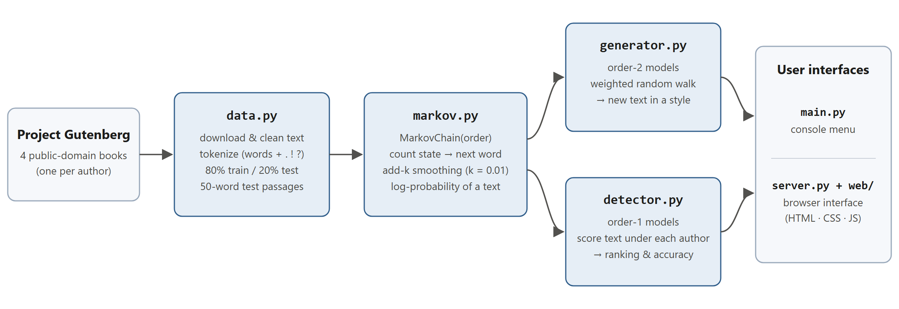
Figure 3: System architecture: from the raw books to the two user interfaces

8.2 Code Snippets
The following snippets are taken directly from the project code [10] (some comments and docstrings are shortened).
def tokenize(text):
"""Split text into lowercase words; . ! ? are kept as tokens."""
text = text.lower().replace("’", "'")
text = re.sub(r"\b(mr|mrs|dr|st)\.", r"\1", text) # "Mr." is not the end of a sentence
return re.findall(r"[a-z]+(?:'[a-z]+)*|[.!?]", text)
Listing 1: Tokenizer (data.py).
def train(self, words):
"""Count every 'state -> next word' pair in the training text."""
for i in range(len(words) - self.order):
state = tuple(words[i:i + self.order])
next_word = words[i + self.order]
self.transitions[state][next_word] += 1

if i > 0 and words[i - 1] in ".!?" and not any(w in ".!?" for w in state):
self.sentence_starts.append(state)

self.vocabulary.update(words)
Listing 2: Counting transitions and sentence starts (markov.py).
def probability(self, state, next_word):
counts = self.transitions.get(state, Counter())
k = self.smoothing
return (counts[next_word] + k) / (sum(counts.values()) + k * (len(self.vocabulary) + 1))

def log_probability(self, words):
total = 0.0
for i in range(len(words) - self.order):
state = tuple(words[i:i + self.order])
total += math.log(self.probability(state, words[i + self.order]))
return total
Listing 3: Smoothed transition probability and log-probability of a passage (markov.py).
def detect_author(models, words):
scores = {author: model.log_probability(words) for author, model in models.items()}
ranking = sorted(scores, key=scores.get, reverse=True)
return ranking, scores

# main.py: all models share one vocabulary
all_words = set().union(*(model.vocabulary for model in models.values()))
for model in models.values():
model.vocabulary = all_words
Listing 4: Author identification and the shared vocabulary (detector.py, main.py).
def generate_text(model, sentences=3, max_words=150):
state = random.choice(model.sentence_starts) # start from pi
words = list(state)
while len(words) < max_words:
counts = model.transitions.get(state)
if not counts:
break
next_word = random.choices(list(counts.keys()), weights=list(counts.values()))[0]
words.append(next_word)
if next_word in ".!?":
sentences -= 1
if sentences == 0:
break
state = tuple(words[-model.order:])
return make_readable(words)
Listing 5: Text generation by a weighted random walk (generator.py).

8.3 Screenshots
Figures 4 and 5 show the browser interface (python server.py). The same features are available in the console menu (python main.py). More screenshots are in the Appendix.
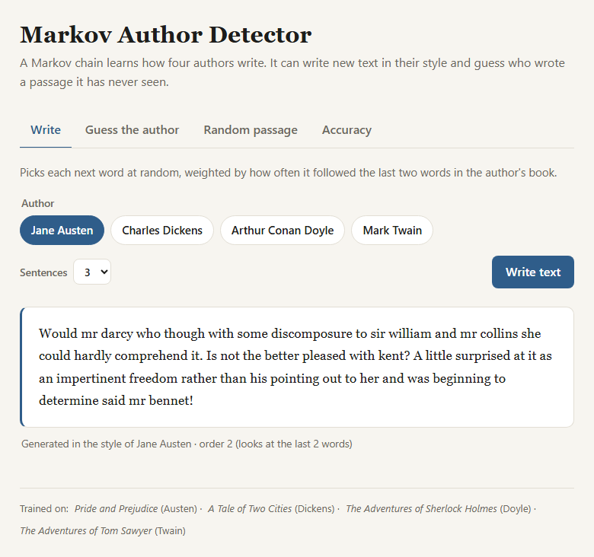
Figure 4: Web interface, “Write” tab: text generated in the style of Jane Austen by the order-2 chain
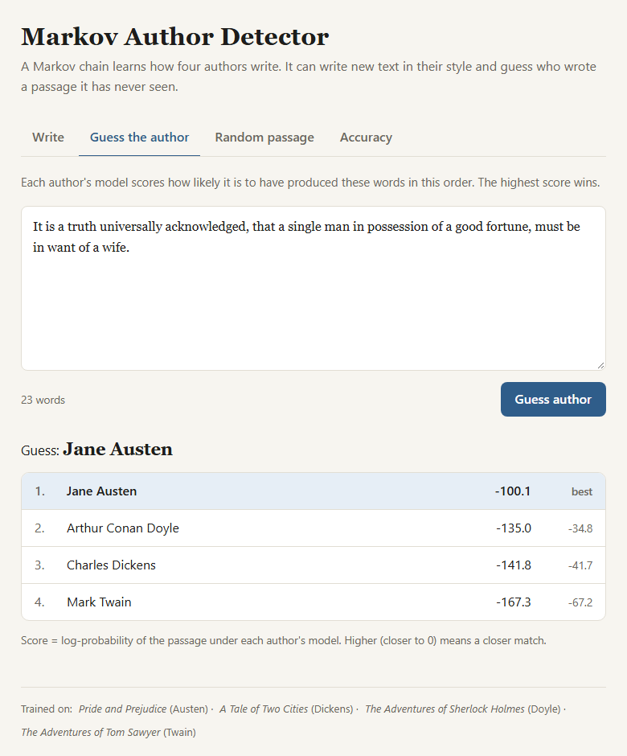
Figure 5: Web interface, “Guess the author” tab: ranking of the four authors for a pasted sentence

8.4 Generated Text
Table 11 shows text generated by the order-2 chains (two sentences each, random seed 7). Each author’s typical vocabulary appears: Austen’s “lady catherine de bourgh” and “mr bingley”, Doyle’s “said he” and a mystery plot, Twain’s short exclamations. The text is fluent over a few words but not meaningful over a whole sentence. Names stay in lowercase because the tokenizer lowercases all text.
Author | Generated text
Jane Austen | Elizabeth soon lagged behind while her daughter and without any inconvenience as lady catherine de bourgh exerted herself much more easily believe mr bingley’s attention to his partner and said with a very charming neighbour in her power. Elizabeth could but just courage enough to be really in love with you at it and could she again took care to inform me that my intimacy has not made elizabeth smile as she could.
Charles Dickens | State your reason. While they examined the stock of his oppressor?
Arthur Conan Doyle | Then he said gravely that is the envelope upon the table and as tenacious as a preliminary to starting for eyford. Some preposterous practical joke said he and laughed heartily.
Mark Twain | I there! Now you hear it?
Table 11: Text generated by the order-2 chains (random seed 7)

8.5 Author Identification Results
All models were tested on the 1,873 unseen 50-token passages from the last 20% of each book. Table 12 and Figure 6 show the accuracy (the share of passages whose predicted author is correct) for each model order. The Average column is the mean of the four authors’ accuracies (macro average).
Table 12: Accuracy on unseen 50-token passages by model order
Model | Austen | Dickens | Doyle | Twain | Average
Order 0 (word frequency, baseline) | 97.2% | 84.7% | 82.1% | 91.2% | 88.8%
Order 1 (used for detection) | 95.7% | 84.7% | 75.4% | 78.9% | 83.7%
Order 2 (used for generation) | 85.4% | 66.8% | 74.1% | 58.8% | 71.3%
Order 3 | 62.1% | 45.8% | 61.6% | 44.8% | 53.6%
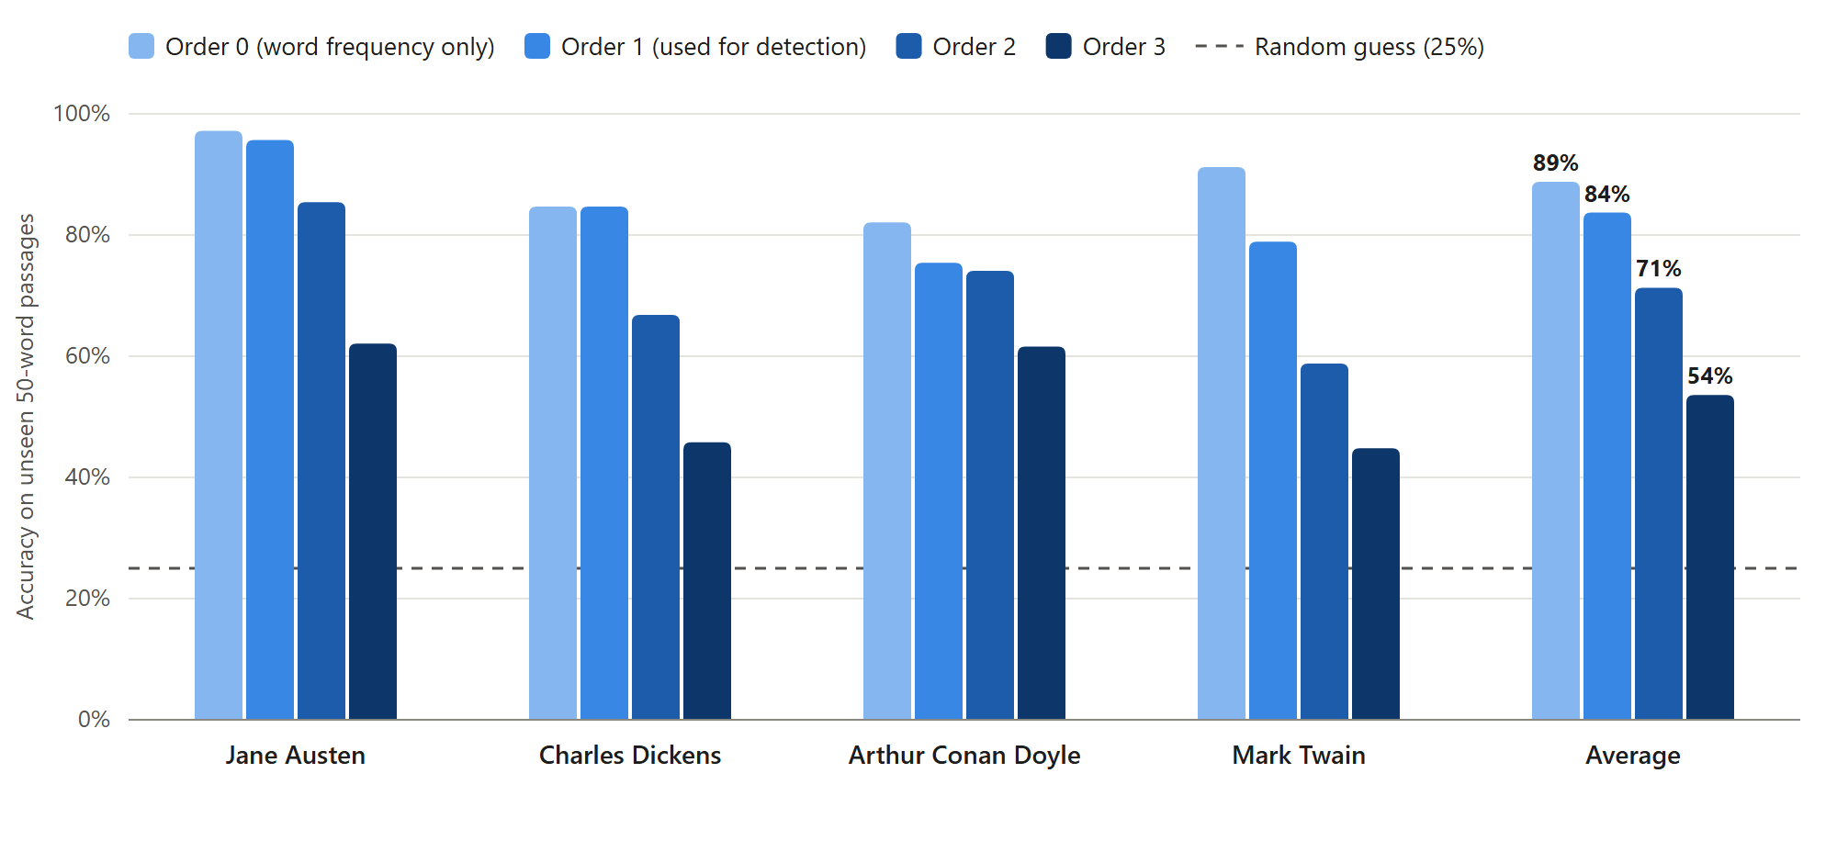
Figure 6: Accuracy by author and model order on unseen passages (dashed line: random guessing)
Table 13 is the confusion matrix of the order-1 detector. The diagonal holds the correct predictions: 1,586 of 1,873 passages, or 84.7% overall (micro average). Recall is the share of an author’s passages that were found; precision is the share of predictions for an author that were right.
Actual \ Predicted | Austen | Dickens | Doyle | Twain | Total | Recall
Jane Austen | 513 | 8 | 15 | 0 | 536 | 95.7%
Charles Dickens | 23 | 492 | 59 | 7 | 581 | 84.7%
Arthur Conan Doyle | 39 | 69 | 338 | 2 | 448 | 75.4%
Mark Twain | 10 | 45 | 10 | 243 | 308 | 78.9%
Total predicted | 585 | 614 | 422 | 252 | 1,873
Precision | 87.7% | 80.1% | 80.1% | 96.4% |  | 84.7%
Table 13: Confusion matrix of the order-1 detector (rows: actual author; columns: predicted author)

Table 14 compares predicted and actual authors for eight randomly chosen test passages (random seed 3). Seven of the eight are correct. The wrong one (row 7) was a close call: the best and second-best scores differ by only 1.6.
# | Start of passage | Actual | Predicted | Best score | 2nd score
1 | The ministers of sainte guillotine are robed and ready. Crash! | Dickens | Dickens ✓ | −361.7 | −382.6
2 | And action that appeared quite supernatural he forced all these changes upon… | Dickens | Dickens ✓ | −330.6 | −364.1
3 | I’m sitting here. But huck we can’t let you into the… | Twain | Twain ✓ | −317.0 | −381.1
4 | Have written to colonel forster to inform him of our present arrangements… | Austen | Austen ✓ | −338.4 | −395.7
5 | They miss us tom? When they get back to the boat… | Twain | Twain ✓ | −302.1 | −361.0
6 | And the heart. There was life and no more. Looking… | Dickens | Dickens ✓ | −352.8 | −360.3
7 | Hatchet! Becky thought her father had never looked so tall and… | Twain | Doyle ✗ | −354.9 | −356.5
8 | Is it far in the cave? I ben on my pins… | Twain | Twain ✓ | −353.6 | −370.9
Table 14: Predicted vs. actual author for eight random test passages

8.6 Steady-State Distribution and Its Meaning
Table 15 gives the steady state of the grouped three-state chain for every author. The share of sentence ends π∞(E) translates directly into sentence length: on average one sentence ends every 1 / π∞(E) tokens, so a sentence has 1 / π∞(E) − 1 words. The results match the sentence lengths measured directly in the books (Table 5).
Author | π∞(E) | π∞(P) | π∞(W) | Words per sentence (1/π∞(E) − 1) | Measured in whole book
Jane Austen | 0.0443 | 0.0644 | 0.8913 | 21.6 | 20.7
Charles Dickens | 0.0520 | 0.0550 | 0.8930 | 18.2 | 17.6
Arthur Conan Doyle | 0.0619 | 0.0764 | 0.8618 | 15.2 | 15.3
Mark Twain | 0.0646 | 0.0634 | 0.8720 | 14.5 | 14.5
Table 15: Steady-state distribution of the grouped chain and what it means

In words: in the long run, about 4.4% of Austen’s tokens end a sentence, so her sentences are the longest (about 22 words), while Twain’s are about one third shorter. Doyle has the highest share of pronouns (7.6%). This fits his books being narrated in the first person by Dr Watson: the word “i” occurs 2,282 times in Doyle’s training text, compared with 1,576 for Austen, 1,336 for Dickens and 605 for Twain. The last two columns differ slightly because the steady state is computed from the training part (80%) and the last column from the whole book.

8.7 Comparison with Baselines and How Well the Markov Assumption Holds
Table 16 compares the detector with simple baselines and with the other model orders.
Method | Average accuracy | Comment
Random guess | 25.0% | One of four authors at random
Always predict the most frequent author (Dickens) | 25.0% (31.0% of all passages) | Dickens has the most test passages: 581 of 1,873
Order-0 word frequencies (no word order) | 88.8% | Strong baseline: vocabulary alone
Order-1 Markov chain (this project) | 83.7% (84.7% of all passages) | More than three times the random baseline
Order-2 Markov chain | 71.3% | More context, but sparse counts
Order-3 Markov chain | 53.6% | Most transitions never seen in training
Table 16: Comparison with baselines (average accuracy over the four authors)

The Markov chain is far better than random guessing or the majority-class baseline. However, the order-0 baseline, which ignores word order and only uses each author’s word frequencies, is better than the order-1 chain (88.8% against 83.7%). The reason is data sparsity. Table 17 shows the share of test transitions that never occurred in the same author’s training text. For order 0, only 2–6% of the test words are new. For order 1, 31–45% of the word pairs are new, and 74–79% of the distinct word pairs in the training text were seen only once. For orders 2 and 3, most transitions are new. Each unseen transition receives only a small smoothed probability, so the score depends more and more on the smoothing and less on real evidence.
Model order | Austen | Dickens | Doyle | Twain
0 (single words) | 1.9% | 3.5% | 4.3% | 5.6%
1 (word pairs) | 31.2% | 38.3% | 36.8% | 45.1%
2 (word triples) | 75.6% | 80.6% | 76.1% | 85.1%
3 (four-word sequences) | 94.5% | 96.5% | 93.7% | 97.3%
Table 17: Share of test transitions never seen in the same author’s training text

So the Markov assumption is useful but only holds over a short window. One preceding word gives real evidence; with two or three preceding words, the training data (one book per author) is far too small to observe most sequences. Higher orders still help generation, because the generator only follows sequences that really occurred, which makes the text more natural.

8.8 How Predictions Change When the Probabilities Change
Smoothing constant k. Table 18 shows the order-1 accuracy for different values of k. The chosen value k = 0.01 gives the best average. A very large k (k = 1, add-one smoothing) flattens all probabilities and hurts Mark Twain most, because his model has the least training data.
k | Austen | Dickens | Doyle | Twain | Average
0.0001 | 92.4% | 80.9% | 73.4% | 77.9% | 81.2%
0.001 | 94.0% | 81.6% | 75.0% | 79.2% | 82.5%
0.01 (used) | 95.7% | 84.7% | 75.4% | 78.9% | 83.7%
0.1 | 97.0% | 87.4% | 74.8% | 69.2% | 82.1%
1 | 96.8% | 86.1% | 70.3% | 46.8% | 75.0%
Table 18: Effect of the smoothing constant k on order-1 accuracy
Setting | Austen | Dickens | Doyle | Twain | Average
k = 0.01, shared vocabulary (used) | 95.7% | 84.7% | 75.4% | 78.9% | 83.7%
k = 0.01, separate vocabularies | 96.3% | 76.2% | 78.3% | 85.4% | 84.1%
k = 1, shared vocabulary | 96.8% | 86.1% | 70.3% | 46.8% | 75.0%
k = 1, separate vocabularies | 99.3% | 32.9% | 65.4% | 70.5% | 67.0%
Table 19: Effect of the shared vocabulary on order-1 accuracy

Passage length. Longer passages contain more transitions, so the evidence for the right author adds up. Table 20 and Figure 7 show that accuracy rises from 50.4% for 5-token passages to 95.8% for 200-token passages. Austen reaches 100%.
Table 20: Effect of passage length on order-1 accuracy
Tokens per passage | Passages | Austen | Dickens | Doyle | Twain | Average
5 | 18,746 | 60.1% | 45.0% | 47.3% | 49.0% | 50.4%
10 | 9,373 | 74.2% | 57.5% | 54.3% | 56.3% | 60.6%
20 | 4,685 | 85.5% | 69.2% | 63.8% | 63.9% | 70.6%
50 (default) | 1,873 | 95.7% | 84.7% | 75.4% | 78.9% | 83.7%
100 | 936 | 98.9% | 91.7% | 89.3% | 84.4% | 91.1%
200 | 468 | 100.0% | 93.8% | 94.6% | 94.8% | 95.8%
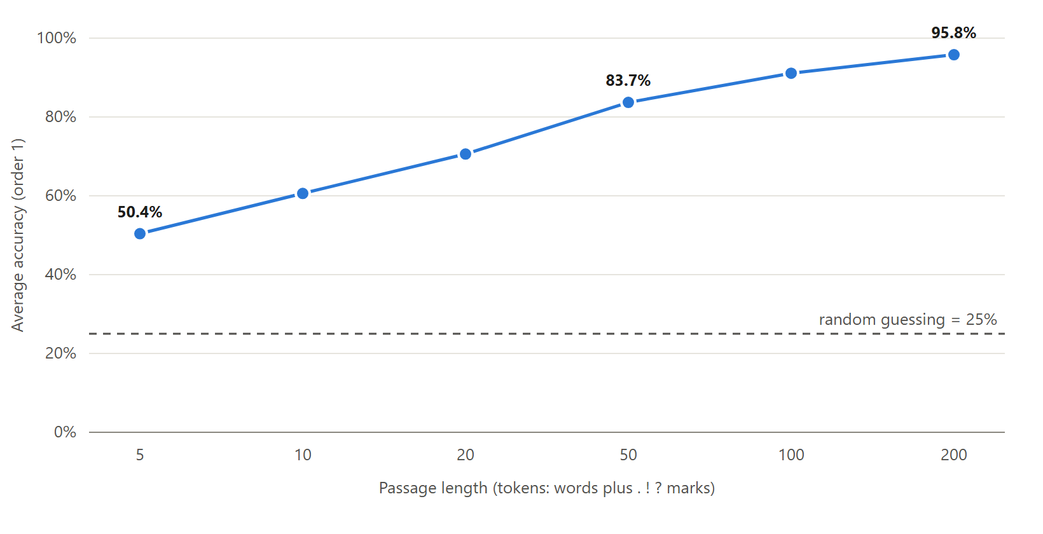
Figure 7: Average order-1 accuracy as a function of passage length

9. Discussion
Why the system works. Authors differ in which word pairs they use and how often. Austen writes “my dear” far more often than the others; Twain’s characters exclaim “my!”; Doyle’s narrator often says “I” and “my friend”. Over 50 tokens these small differences add up to a clear difference in log-probability, so the detector reaches 83.7% average accuracy with nothing more than counting and division. Part of this success also comes from content rather than pure style: character names such as “elizabeth”, “holmes” or “tom” and story-specific words are strong clues, because training and test passages come from the same book.
Differences between authors. Jane Austen is the easiest author (95.7% recall). Twain has the highest precision (96.4%) but a lower recall (78.9%): when the model says “Twain” it is almost always right, but many Twain passages (45 of 308) are assigned to Dickens. Twain’s book is the shortest (61,724 training tokens), so 45.1% of his test word pairs never appear in his training text, more than for any other author, and his model has the least evidence. Dickens and Doyle are often confused with each other (59 and 69 passages), which is reasonable for two nineteenth-century British authors writing narrative prose.
Unexpected results. Two results were surprising. First, the order-0 word-frequency baseline beats the order-1 Markov chain for detection (88.8% against 83.7%). With only one book per author, single-word frequencies are estimated much more reliably than word-pair frequencies (Section 8.7). The Markov chain is still needed for generation, and it ties with the baseline on Dickens. Second, the shared vocabulary hardly matters at k = 0.01 but matters a lot at k = 1. The project README records that, before the shared vocabulary was added, almost every passage was labelled Jane Austen; our measurements reproduce that bias only with strong smoothing (k = 1), not with the final k = 0.01.
Failure cases. Very short passages are unreliable: with 5 tokens the accuracy is only 50.4%. Close calls such as row 7 of Table 14 (a Twain passage given to Doyle by a margin of 1.6) show that the decision can depend on a few rare word pairs. Generated text loses meaning after a few words and keeps names in lowercase.
Ethical and social issues. Authorship attribution can be misused to unmask anonymous writers, such as whistle-blowers, journalists or critics, which can put them at risk. A wrong attribution can also harm an innocent person, for example a student wrongly accused of copying. With about one passage in six misattributed, the output must be treated as weak evidence and never as proof. The system also always picks one of its four authors, even when the true author is someone else. Text generation could be used to imitate a real person’s writing, so generated text should be clearly labelled. The project uses only public-domain books and stores no personal data.

10. Conclusion and Future Work
The project built a complete, explainable system for author identification and text generation using Markov chains. Table 21 compares the results with the objectives from Section 1.3.
Objective | Result | Status
O1: Markov chain models for four authors with the standard library only | Order 0–3 chains built for four authors from 374,941 training tokens; training takes under one second per order | Achieved
O2: At least 80% average accuracy on unseen 50-word passages | 83.7% average (84.7% of all 1,873 passages); 95.8% on 200-token passages | Achieved
O3: Generate text in each author’s style | The order-2 chain writes locally fluent sentences with each author’s vocabulary; coherence beyond a few words is limited | Achieved
O4: Interface and evaluation of order, smoothing and length | Console menu and web interface; effects of order, smoothing, shared vocabulary and passage length measured | Achieved
Table 21: Objectives and what was achieved

The main lesson is the trade-off of the Markov assumption: a longer memory produces better text but needs far more data to estimate, so for author identification a short memory works best with one book per author.
Future work:
- Combine model orders. Use interpolation, P = λ₀P₀ + λ₁P₁ + λ₂P₂, or back-off smoothing [8], with the weights λ tuned on held-out text. This would join the reliability of word frequencies with the context of longer chains.
- Measure style rather than story. Train on several books per author, test on a different book, and remove character names, so that the detector cannot rely on names and plot.
- Bangla support. Replace the English tokenizer with a Unicode-aware one and train on a Bangla literature corpus, such as the one used by Khatun et al. [6]. Restoring capital letters for names in generated English text is a smaller improvement.

11. References
[1] A. A. Markov, “An example of statistical investigation of the text Eugene Onegin concerning the connection of samples in chains,” Science in Context, vol. 19, no. 4, pp. 591–600, 2006 (English translation of the 1913 original).
[2] C. E. Shannon, “A mathematical theory of communication,” Bell System Technical Journal, vol. 27, pp. 379–423 and 623–656, 1948.
[3] F. Mosteller and D. L. Wallace, “Inference in an authorship problem,” Journal of the American Statistical Association, vol. 58, no. 302, pp. 275–309, 1963.
[4] D. V. Khmelev and F. J. Tweedie, “Using Markov chains for identification of writers,” Literary and Linguistic Computing, vol. 16, no. 3, pp. 299–307, 2001, doi: 10.1093/llc/16.3.299.
[5] F. Peng, D. Schuurmans, V. Keselj, and S. Wang, “Language independent authorship attribution with character level n-grams,” in Proc. 10th Conf. European Chapter of the Association for Computational Linguistics (EACL), 2003, pp. 267–274, doi: 10.3115/1067807.1067843.
[6] A. Khatun, A. Rahman, and M. S. Islam, “Authorship attribution in Bangla literature using character-level CNN,” in Proc. 22nd Int. Conf. Computer and Information Technology (ICCIT), 2019, doi: 10.1109/ICCIT48885.2019.9038560.
[7] E. Stamatatos, “A survey of modern authorship attribution methods,” Journal of the American Society for Information Science and Technology, vol. 60, no. 3, pp. 538–556, 2009.
[8] D. Jurafsky and J. H. Martin, “N-gram language models,” in Speech and Language Processing, 3rd ed. draft, ch. 3. [Online]. Available: https://web.stanford.edu/~jurafsky/slp3/
[9] Project Gutenberg. [Online]. Available: https://www.gutenberg.org (eBooks no. 1342, 98, 1661 and 74).
[10] Team CodeCrafters, “markov-author-detector,” GitHub repository, 2026. [Online]. Available: https://github.com/nusratnodi/markov-author-detector

12. Appendix

A. Source Code
The full source code, the presentation slides and this report are available on GitHub: https://github.com/nusratnodi/markov-author-detector [10]. Table 22 lists the files.
File | Purpose
data.py | Downloads the books, removes the Gutenberg header, tokenizes, splits 80/20 and cuts test passages
markov.py | The MarkovChain class: transition counts, sentence starts, smoothed probability, log-probability
generator.py | Generates text by a weighted random walk and makes it readable
detector.py | Guesses the author of a passage and measures accuracy
main.py | Trains the models and runs the console menu
server.py | Small local web server that connects the browser page to the Python code
web/index.html, web/style.css, web/app.js | The browser interface
data/ | The four downloaded books (created on the first run)
Table 22: Project files

B. User Manual
Requirements: Python 3 only; no packages need to be installed. An internet connection is needed once, on the first run, to download the four books. On Windows, type python (on macOS or Linux, python3).
- Download the code: git clone https://github.com/nusratnodi/markov-author-detector.git, then cd markov-author-detector.
- Console version: run python main.py. After the models are trained, choose from the menu: 1 = write new text in an author’s style; 2 = paste a passage and guess its author (press Enter on an empty line to finish); 3 = guess the author of a random unseen passage; 4 = measure the accuracy of orders 1–3; 5 = quit.
- Web version: run python server.py. The browser opens http://localhost:8000. Use the tabs “Write”, “Guess the author”, “Random passage” and “Accuracy”. Keep the terminal open while using the page and press Ctrl+C to stop the server. If port 8000 is busy, run python server.py 8080.

C. Additional Results
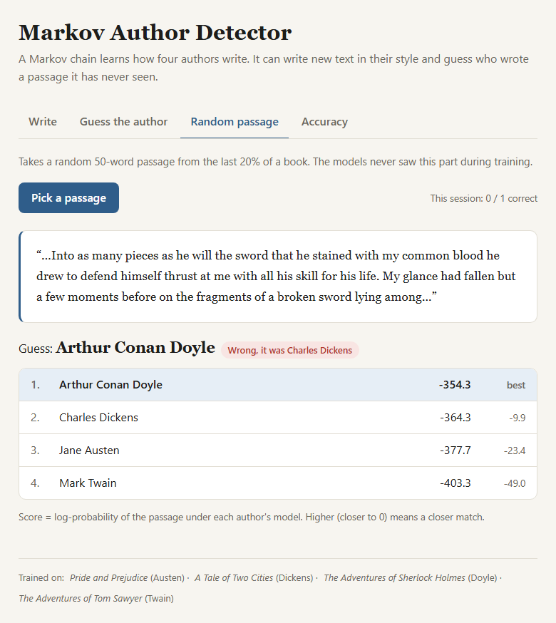
Figure 8: Web interface, “Random passage” tab: a wrong guess (Doyle) for a Dickens passage, with the real author shown
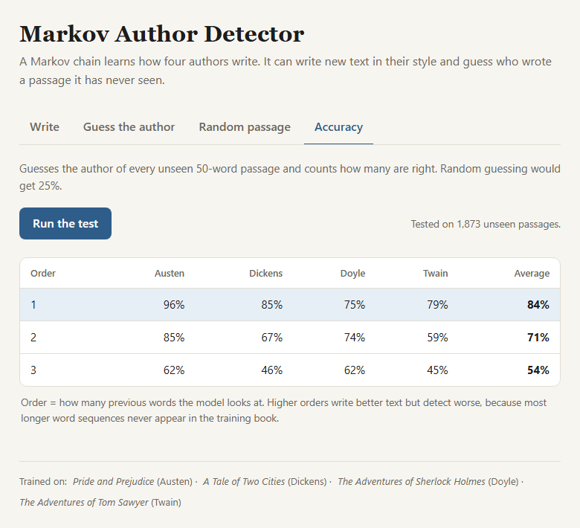
Figure 9: Web interface, “Accuracy” tab: the evaluation of orders 1–3 on 1,873 unseen passages

Contribution Table
Each member wrote one module of the program, and all members worked together on the main program, the web interface, the testing, this report and the presentation.
Table 23: Contribution of each team member
Student ID | Name | Contribution
04324205101199 | Maliha Mahjabin Tasnim | data.py: downloading the books, cleaning the text, tokenization, train/test split and test passages
04324205101208 | Maimuna Nowshen Mahima | markov.py: the MarkovChain class, transition counting, add-k smoothing and log-probability
04324205101209 | Maksuda Akter Mohona | generator.py: text generation by weighted random walk and readable output
04324205101211 | Nusrat Jahan | detector.py: author detection, evaluation and accuracy measurement
All members |  | main.py console menu, web interface (server.py, web/), testing, report and presentation slides

